**REPORT**

**TASK 1**

**ANALYZING RESTAURANT REVIEWS**

**INTRODUCTION**

This project focuses on collecting, analyzing, and visualizing customer reviews from a particular restaurant, The Pawn Shop. The main objective is to understand the sentiments of customers who rate the restaurant. This analysis helps the restaurant's management to better understand customer feedback and sentiments, enabling them to make improvements based on customer needs.

**DATA COLLECTION:**

1. Collect recent customer reviews from the chosen restaurant ‘The Pawn Shop’.
2. While collecting data, make sure that you are making note of the ratings and the review date along with the review. The reason for collecting review date’s is to visualize the data for better understanding.
3. Store the data in an excel spreadsheet.

**DATA ORGANIZATION:**

1. **Review ID**: Unique identifier for each review.
2. **Rating**: Numerical rating (1 to 5 stars) given by the customer.
3. **Review Text**: The textual content of the review.
4. **Sentiment**: The inferred sentiment of the review (Positive, Neutral, Negative).
5. **Review Date**: The date when the review was posted.

**DATA ANALYSIS:**

1. **Descriptive Analysis:**

Average Rating**:** The average rating of the restaurant was calculated to understand the overall customer satisfaction.

1. **Sentiment Analysis:**
2. **Positive Reviews**: Reviews with ratings of 4 or 5 stars were considered positive.
3. **Neutral Reviews**: Reviews with a rating of 3 stars were considered neutral.
4. **Negative Reviews**: Reviews with ratings of 1 or 2 stars were considered negative.

**COMMON THEMES:**

**Frequent Positive Comments:** Identified common themes in positive reviews such as "fantastic food", "great ambiance", "attentive staff", and "unique dining experience".

**Frequent Negative Comments:** Identified common themes in negative reviews such as "slow service", "overhyped", and "pricey".

**VISUALIZATION:**

To better understand and communicate the findings, the following visualizations were created:

* **Bar Chart for Ratings Distribution:** Displays the frequency of each rating.
* **Pie Chart for Sentiment Analysis:** Shows the proportion of positive, neutral, and negative reviews.
* **Time Series Visualization:** Illustrates the trend of ratings over time.

**FINDINGS:**

**Overall Sentiment:** The overall sentiment is predominantly positive, with the majority of reviews giving 4 or 5-star ratings.

**Average Rating:** The average rating is calculated to be around 4.2 stars, indicating general customer satisfaction.

**Common Positive Aspects:** Customers frequently praised the unique and fun dining experience, the ambiance, and the quality of food and service.

**Common Negative Aspects:** Negative feedback highlighted issues like slow service and high prices.

**DATASET:**

[restaurant review analysis.xlsx](https://1drv.ms/x/c/f171cdce1c65c95e/Efg03swmFQ9ChRoaRnixjDcBGfp4f6dN9wkzi7dNI3l4-Q?e=0dZGkC)

**CODE:**

import pandas as pd

import numpy as np

import matplotlib.pyplot as plt

import seaborn as sns

data = {

    "Review ID": [1, 2, 3, 4, 5, 6, 7, 8, 9, 10, 11, 12, 13, 14, 15, 16, 17, 18, 19, 20, 21, 22, 23, 24, 25, 26, 27, 28],

    "Rating": [5, 5, 5, 5, 5, 5, 5, 5, 5, 5, 5, 5, 5, 5, 5, 5, 4, 4, 4, 4, 4, 4, 3, 3, 3, 2, 1, 1],

    "Sentiment": ["Positive", "Positive", "Positive", "Positive", "Positive", "Positive", "Positive", "Positive", "Positive", "Positive", "Positive", "Positive", "Positive", "Positive", "Positive", "Positive", "Neutral", "Neutral", "Positive", "Positive", "Positive", "Positive", "Negative", "Negative", "Negative", "Negative", "Negative", "Negative"]

}

df = pd.DataFrame(data)

# Bar Chart

plt.figure(figsize=(10, 6))

sns.countplot(x='Rating', data=df, palette='viridis')

plt.title('Ratings Distribution')

plt.xlabel('Rating')

plt.ylabel('Number of Reviews')

plt.show()

# Pie Chart

sentiment_counts = df['Sentiment'].value_counts()

plt.figure(figsize=(8, 8))

plt.pie(sentiment_counts, labels=sentiment_counts.index, autopct='%1.1f%%', startangle=140, colors=['#ff9999','#66b3ff','#99ff99'])

plt.title('Sentiment Distribution')

plt.show()

# Calculating the Average Rating

average_rating = df['Rating'].mean()

print(f'Average Rating: {average_rating:.2f}')

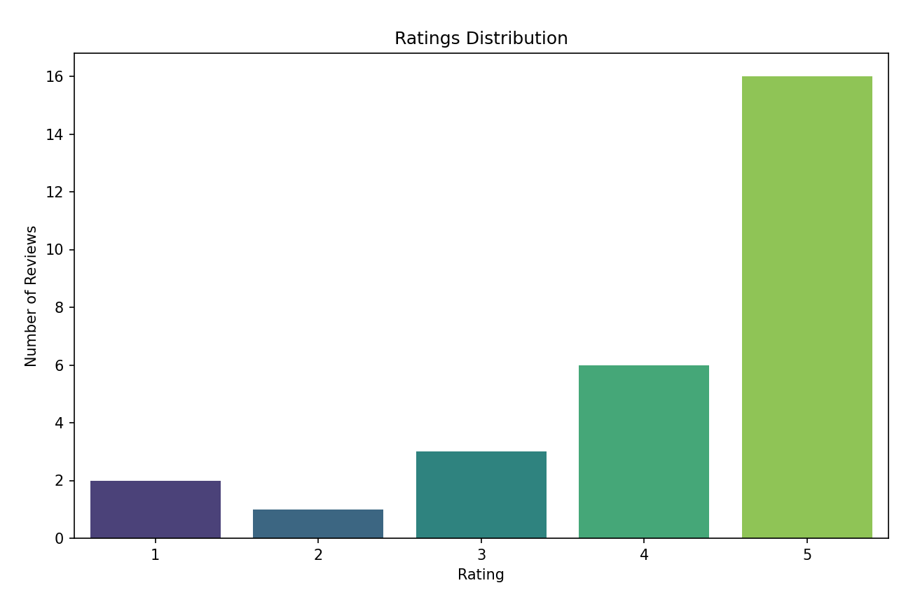

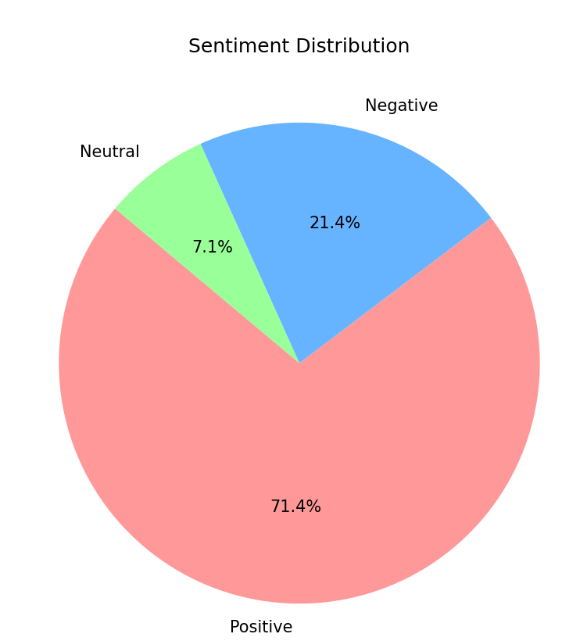

**POWERBI TEMPLATE:**

[Customer Review Analysis.pbix](https://1drv.ms/u/c/f171cdce1c65c95e/Ea_1GeuECPBCg2uCvX_hmI4BqJLLgD97Kj-_AWT67brJew?e=dEITh9)

**CONCLUSION:**

The analysis reveals that The Pawn Shop enjoys a favorable reputation among its patrons, with high ratings and positive sentiments dominating the reviews. However, addressing the few negative aspects like service speed and pricing could further enhance customer satisfaction. This comprehensive review analysis provides valuable insights for potential customers and can help the restaurant in making informed decisions to improve their service.

|  |  |  |  |  |  |
| --- | --- | --- | --- | --- | --- |
|  |  |  |  |  |  |
|  |  |  |  |  |  |
|  |  |  |  |  |  |
|  |  |  |  |  |  |
|  |  |  |  |  |  |
|  |  |  |  |  |  |
|  |  |  |  |  |  |
|  |  |  |  |  |  |
|  |  |  |  |  |  |
|  |  |  |  |  |  |
|  |  |  |  |  |  |
|  |  |  |  |  |  |
|  |  |  |  |  |  |
|  |  |  |  |  |  |
|  |  |  |  |  |  |
|  |  |  |  |  |  |
|  |  |  |  |  |  |
|  |  |  |  |  |  |
|  |  |  |  |  |  |
|  |  |  |  |  |  |
|  |  |  |  |  |  |
|  |  |  |  |  |  |
|  |  |  |  |  |  |
|  |  |  |  |  |  |
|  |  |  |  |  |  |
|  |  |  |  |  |  |
|  |  |  |  |  |  |
|  |  |  |  |  |  |
|  |  |  |  |  |  |
|  |  |  |  |  |  |
|  |  |  |  |  |  |
|  |  |  |  |  |  |
|  |  |  |  |  |  |
|  |  |  |  |  |  |
|  |  |  |  |  |  |
|  |  |  |  |  |  |
|  |  |  |  |  |  |
|  |  |  |  |  |  |
|  |  |  |  |  |  |
|  |  |  |  |  |  |
|  |  |  |  |  |  |
|  |  |  |  |  |  |